4xS

1.Our team

* Stefan Georgiev Diomov Scrum trainer
* Stefan Plamenov Ganchev Front end developer
* Stoicho Denchev Dimitrov Back end developer

2. How it all works.

We

Class Files:

* .h = We define what properties and methods this Class has and decide how to expose them.
* .cpp = These hold the implementation of what was written in the Header file.

All our Class files have a similar structure:

-Attributes – Data connected to the class – id, name, description, address, etc.

- Getters() - Methods that return that data and don’t accept parameters.

-Setters() - Methods that accept data, don’t return data “void”

-CRUD - create, read, update, destroy

* Main.cpp = different menus All our menus have a similar structure:

-teamsmenu

-readAll();

-read();

-create();

update();

destroy();

-studentsmenu

-CRUD();

-schoolsmenu

` -CRUD();

-techersmenu

-CRUD();

Every menu’s Update method opens up a new Menu, in which you have to specify the Id of the item you want to edit – if you want to edit a student, you need to specify a valid student Id.

Once a valid ID has been received from the user, we read the data of the item they want to edit, display it on screen and provide them with menu options that allow them to edit the item in any way they want.

In every menu the last option is Save and Stop editing, which will take the current item’s data (that the user just edited) and save it to a file.

* Main menu – the interface of the program
* Start - the condition to show the interface
* Main - Color of the text, start funtion

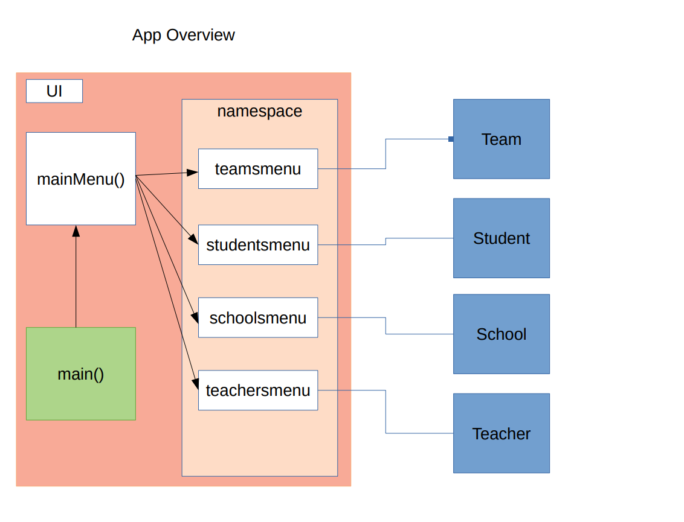

3. Our future ideas

- To add active property to the student , teacher, and the school

- To add UI(user interface)

- To replace the .csv files with database